Tray Tables.ai

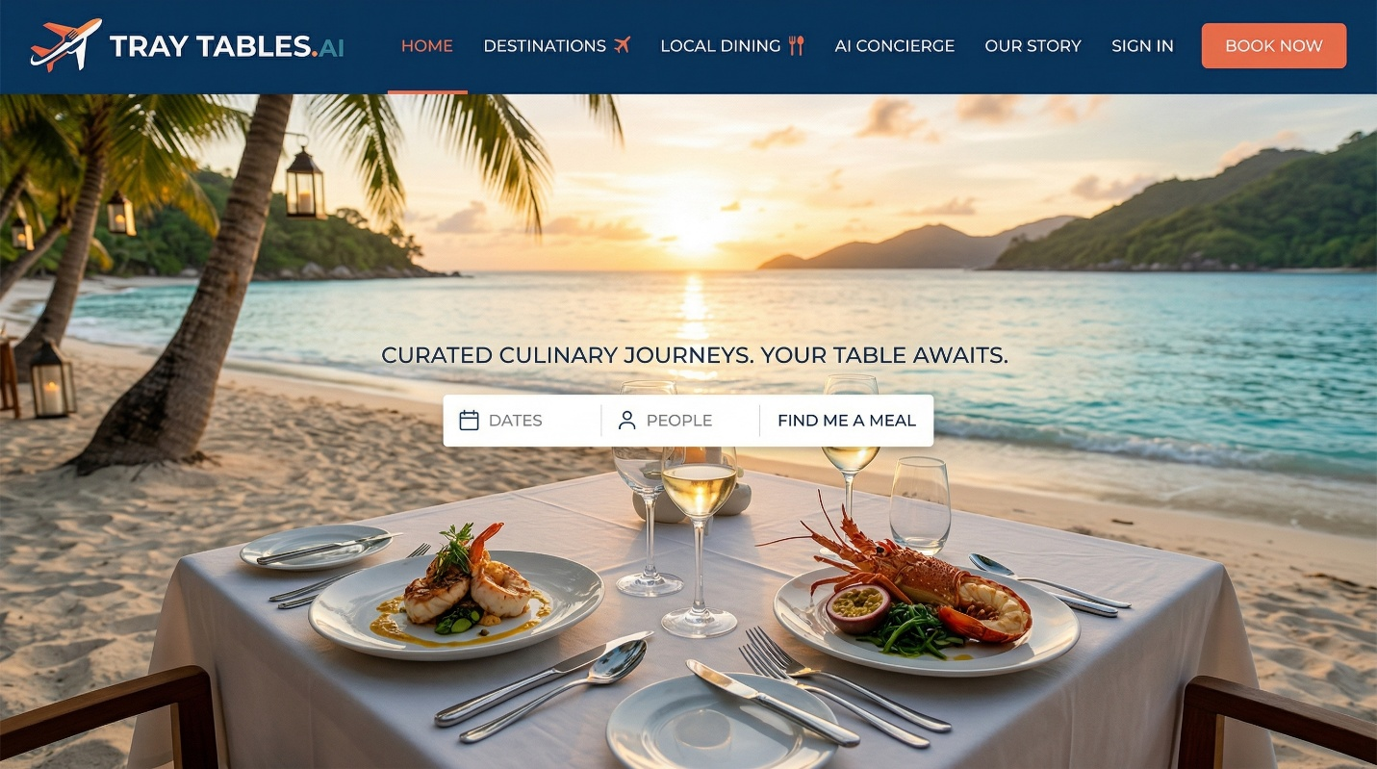
- Jobs to be done
  - Find dishes to eat that are unique to the area that you are traveling in
  - Find restaurants that showcase regional dished
    - Canonical regional dishes per location
    - Dish metadata
      - Explanation of what it is, what in it and a brief history, and how that history relates to the region
  - Find restaurant based in the neighborhoods / areas that you are traveling in
  - Ability to plan breakfast, lunch, dinner, snack, street food for the number of days you are traveling (limited to 14 total days)
  - Optimize a route based on neighborhoods and restaurants you want to eat at
  - Configure what type of eater you are
      - Vegie lover
      - Adventures foods – seeks unfamiliar cuisines & dishes
      - Comfort Seeker – familiar foods, low surprise
      - Local Purist – only eats hyper-local or traditional
        - Heavily weight:
          - Reviews written in the local language
          - Repeat visitors
          - Locals’ dish-specific feedback
          - Longevity (years in operation)
      - Trendy Explorer – chases viral or buzzworthy spots
        - Heavily weight
          - Tourist reviews
          - Influencer and social content
      - Street Food Lover
      - Fine Dining Enthusiast
      - Foodie Completist – “best ramen / best pizza / must-try lists”
    - Dietary & Health Constraints (Hard filter)
      - Vegetarian / Vegan (strict vs flexible)
      - Gluten-Free
      - Dairy-Free / Lactose-Free
      - Nut Allergy
      - Shellfish Allergy
      - Halal
      - Kosher
      - Alcohol free (setting for the drink pairings)
      - Make sure the user know that results are ai generated and we cannot ensure their health safety at any resurant, and they may not serve the approate dishes for their preferences. They should always contact the restaurant prior to reserving / going.
    - Price
      - Set parameters for how much you are willing to spend
    - Spice preference
      - High, medium, low
  - Help prioritizing foods and restaurants
    - What are the must eats for 1st timers
    - Vs, what should repeat visitors be looking into
  - Timing Intelligence
    - Peak vs off-peak hours
    - When locals eat this dish
    - When restaurants run out
    - Closed days / siesta logic
  - Have tags for restaurants based on information
    - Tags
      - Great views
      - Service etc.
      - Lively atmosphere
      - Outdoor seating
      - Pet friendly
      - Child friendly
      - Tasting menu
      - Large portions
      - Romantic
      - Great cocktails
  - Show cuisine type
    - Italian
    - Japanese
    - Mexican
    - French
    - Thai
    - Indian
    - Mediterranean
    - Southern
    - Asian fusion
    - Seafood
  - Be able to see pictures of specific menu items
    - Search web and social media
  - Be able to see menus
  - Recommendation on what to eat including the must eat regional dishes
    - Wine and drink parings if they opt in
  - Be able to link to reserve a table
  - Utilize “trusted resources”
    - Michelle guide
    - Eater
    - Thrill list
    - The infatuation
    - Thefork
    - Michelin Guide
    - Local ublication
    - Local guides
    - Google maps
    - wikipedia
  - Accessibility notes
    - Look to google/reddit to determine lines, reservation needs, and language barriers
  - Ability to save itineraries and maps offline
  - Ability to record experience from restaurants.
    - Store pictures
    - Tage meals
    - Share information with other travelers on platform
- Target Customer & Context
  - First‑time visitors vs repeat travelers
  - Solo vs group / couple travels
  - Decision‑making time horizon (now vs planning)
- Success Definition
  - Users use app and are able to find unique foods and resturants, make reservation, and record / share their unique experiences
  - Users try 2+ new dishes
  - Reduced time for planning and research when traveling
  - Better confidence vs google/ yelp
  - Repeat usage across trips
- Strategic Alignment
  - Builds proprietary regional food intelligence
  - Differentiates from generic maps/reviews
  - Creates reusable trust/performance scoring
- User journey
  - User sets up trip information
    - User has trip planned outside of their home city or home country- used states what city(s) they will be traveling to
    - User has dates decided
    - User has idea of what areas they will be in based on the different days, or they leave this section blank
    - User can selec if they want reccomendations for breakfast, lunch, dinner, late night, street food, buy day
  - User sets up food preferences
    - What type of eater are you:
      - Examples (user is able to select many)
        - Adventures foods – seeks unfamiliar cuisines & dishes
        - Comfort Seeker – familiar foods, low surprise
      - Dietary & Health Constraints (Hard filter)
        - Examples
          - Vegetarian / Vegan (strict vs flexible)
          - Gluten-Free
      - Spice preference
      - 1st time visitor vs multiple visits
    - User will get back 2 sections:
      - Must try dishes
        - This will be derived from “trusted resources”
        - Canonical regional dishes per location
        - Dish metadata
        - Explanation of what it is, what in it and a brief history, and how that history relates to the region
      - Restaurants recommendations
        - Restaurants will be listed by day, meal (breakfast, lunch, dinner, snack) and neighborhood/location
        - Key menue items including “must try dishes will be listed”
        - Will give any narrative based info on the restaurant
        - Will provide picture of 1) the out side and 2) a key dish
        - Tags will be added – tags such as great views
        - Will show cuisine type
        - Will show price range
        - Will show spice rating
        - Will “show the eater type”
        - Like out to restaurant website or google page
        - Info such as reservation, hours or any other info is provided
        - Can click link to full menus
      - Selection for trip itinerary
        - User can lock in each selection
        - If user does not like the selection they can give a short prompt on why they do not like it and re run the model
        - User can cancel if they do not want a recommendation for that day/ meal
      - Reservations
        - Selected restaurants will generate a reservation link if reservations are taken
      - Final itinerary
        - Once finalized a full itinerary is generated and savable in the application or printable along with a summary of information on the restaurant as well as the must try dishes
      - After dining-user generated content and storage
        - User can use their itinerary to record information on their dining
          - Images
          - Rating 1 to 5
          - Open form notes on their experience
          - Tags- they can tag items they experienced (great service etc.)
          - Make public – they can share their generated content with others on the platform
          - Export – they can export specific trips to a document
          - User achievements – they can see how many resultants they have been to, how many countries, how many continents how many Michelin stars or bib gourmand, James Beard selections, resultants repeated, number of cuisines, the restaurants the rated the highest and other achievements.
            - Examples of achievements
              - Prestige & Quality Achievements
              - (High-signal, status-driven)
              - Michelin Hunter – Dined at X Michelin-starred restaurants
              - Three-Star Legend – Visited a 3-Michelin-star restaurant
              - Bib Gourmand Explorer – Visited X Bib Gourmand restaurants
              - Critics’ Choice – Visited X award-winning restaurants (James Beard, Worlds 50 Best, etc.)
              - Chef Follower – Dined at restaurants by X notable chefs

              - 🌍 Geographic Exploration
              - (Travel + discovery motivators)
              - Global Diner – Dined in X countries
              - Continental Taster – Dined on X continents
              - City Conqueror – Visited X restaurants in one city
              - Hidden Corners – Dined in X off-the-beaten-path locations
              - Local Legend – Visited X restaurants within one metro area

              - 🍽️ Volume & Consistency
              - (Progression and habit-building)
              - First Bite – First restaurant visited
              - Foodie 25 / 50 / 100 – Total restaurants visited
              - Power Eater – X restaurants in 30 days
              - Marathon Diner – X restaurants in a single trip
              - Repeat Favorite – Returned to the same restaurant X times

              - 🧭 Culinary Adventure
              - (Personal taste & exploration)
              - Adventurous Eater – Tried X different cuisines
              - Regional Specialist – Focused heavily on one cuisine or region
              - Street to Stars – Visited street food → fine dining
              - Seasonal Seeker – Dined seasonally in X different seasons
              - Chef’s Tasting Regular – Tried X tasting menus

              - 🥗 Dietary & Preference-Based
              - (Personalization & inclusivity)
              - Plant-Powered – Visited X vegetarian/vegan restaurants
              - Allergy-Aware – Found X allergy-friendly restaurants
              - Healthy Choices – Chose X healthy-focused restaurants
              - Carnivore Club – Focused on steak, BBQ, or meat-centric dining

              - 🍷 Experience & Occasion
              - (Social and situational moments)
              - Date Night Pro – Visited X romantic restaurants
              - Group Feast – Dined with groups of X+ people
              - Celebration Expert – Used restaurants for birthdays/anniversaries
              - View Chaser – Dined at X restaurants with notable views
              - Late-Night Legend – Dined after midnight X times

              - 📝 Contribution & Community
              - (Network effects and trust)
              - First Review – Posted first review
              - Trusted Taster – X high-rated reviews
              - Photo Foodie – Uploaded X food photos
              - Trend Spotter – Visited restaurants early before popularity spikes
              - Guide Maker – Created X restaurant lists or guides

              - 🏆 Meta / Elite Tiers
              - (Long-term engagement)
              - Rising Foodie – Early milestone achiever
              - Certified Foodie – Crossed core achievement thresholds
              - Elite Diner – High prestige + volume + geography combined
              - World-Class Palate – Top percentile user based on diversity + quality
          - Achievements are visible on users public profile if they make them visible

Copilot food and restaurant prompt:
Goal: Create a database - structured data that will provide the best dishes to eat in each city, and the best restaurants to experience these dishes for each city. Agent will identify canonical dishes for each city. There will be a minimum of 10 dished per city with a maximum of 20 dishes per city. Agent will then do a search to find a minimum of 1 and maximum of 10 restaurants per city that serve that dish. For each restaurant it needs to tag the restaurant based on: price, vegetarian options, local favorites (restaurants highly regarded by locals), trendy ( restaurants trending on social), street food (is this a street vendor or not), what time they are open (breakfast, lunch, dinner, late night). The agent will also provide a drink pairing. this will be a well rated drink, either alcoholic or not (preference towards alcoholic beverages - mix drinks etc.).

Look at all of the web but prioritize these sources: https://tabelog.com/en/, https://guide.michelin.com/us/en, https://www.eater.com/,https://www.theinfatuation.com/, google.com/maps, https://www.timeout.com/, https://www.theinfatuation.com/, https://www.tripadvisor.com/

put information in an excel table
Data
Prompt
- Create a table with the following columns:
  - City, Country, Canonical Dish, Restaurant, Neighborhood/Area, Price, Vegetarian Options, Local Favorite, Trendy, Street Food, Hours, Why This Place, Drink Pairing, Source
- For canonical dishes google the top dishes that you must try in that city
  - Provide 10 dishes for each city
- For restaurant find the best restaurant that serves that dish.
  - Search the internet but prioritize the following sources: https://tabelog.com/en/, https://guide.michelin.com/us/en, https://www.eater.com/,https://www.theinfatuation.com/, google.com/maps, https://www.timeout.com/, https://www.theinfatuation.com/, https://www.tripadvisor.com/
- For price use from one to four currency sysmbols in the local currency
- For vegetarian option return either “Yes” or “Limited” base on the vegetarian options the restaurant has
- Indicate a yes or no for “local favorite” (restaurants highly regarded by locals), “trendy” ( restaurants trending on social), and “street food” (is this a street vendor or not) based on the restaurant
- For hours used the restaurant’s hours to determine if it is all breakfast, lunch dinner, or late night. Multiple options can be shown
- For why this place give once sentence on why this dish is canonical including its relevance to the region, and give one sentence on why this restaurant. If restaurant information is unavailable, you can omit the 2nd sentence.
- For drink paring give an alcoholic beverage from the restaurant’s menu. If one is not available provide a popular regional drink
- For source give the source that you found the restaurant as a full url
- Do not use the same restaurant for more than one canonical dish
- Format guarantees
  - TAB delimited only
  - No commas anywhere inside any cell
  - ASCII only inside the table
  - 14 columns per row
  - Hours is single token only from Breakfast Lunch Dinner LateNight AllDay N/A
  - 10 dishes per city
  - Source is URL only

Prompt #2

for this data 1) Find the address of the restaurant 2) find a link to the restaurant (google, or the restaurant's web site)
Return this to me in a table with the following rules "
o TAB delimited only
o No commas anywhere inside any cell
o ASCII only inside the table
o 2 columns per row

information will be provided in the following format:
City Country Canonical Dish Restaurant Neighborhood/Area Price Vegetarian Options Local Favorite Trendy Street Food Hours Why This Place Drink Pairing Source

